**[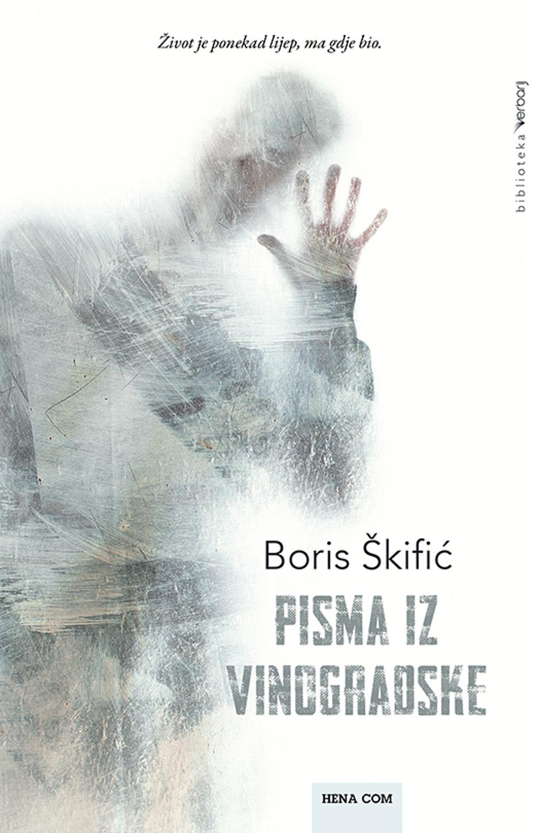](https://www.vecernji.hr/media/img/8b/bf/76f790d0f4e241c1d2df.jpeg)**

